**Virtual Lab: Measurement, Precision And Significant Figures**

**Objective:**

The aim of this lab is to practice recording measurements with the correct precision.

**Background: Uncertainty in Measurement**:

It is important to realize that any measurement will always contain some degree of uncertainty. The uncertainty of the measurement is determined by the scale of the measuring device. The smaller the unit you use to measure with, the more precise the measurement is.

**Precision vs. Accuracy:**

**Precision**- how close individual measurements agree with each other.

**Accuracy**- how close individual measurements agree with the true or accepted value.

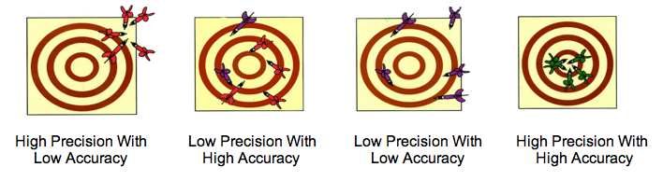

Accurate number = small errors

Precise number = small uncertainty

In General, the uncertainty of a measurement is determined by the precision of the measuring device. **The smaller the unit you use to measure with, the more precise the measurement is.** For example a 100mL graduated cylinder with 1mL graduation will have an uncertainty of +/- 0.1 mL. **When making a measurement you must always estimate 1 place past the smallest division.**

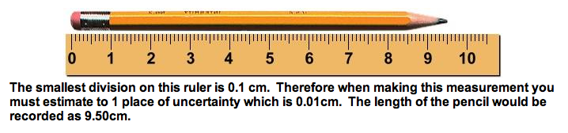

**Procedure:**

Several sub stations have been set up in this virtual lab. For each sub station, read the directions, and read the measurements according to the directions. Record these measurements with the correct units in the slot in your data table that corresponds to the station number. Remember to estimate to 1 place of uncertainty for each measurement. Then determine the number of significant figures for each measurement.

|  |  |  |
| --- | --- | --- |
| **Station 1:**   1. Buret:   Directions: Measure the liquid in the Burets. Burets are measured from the *top down.* Don't forget to measure to one place of uncertainty. | Picture  Buret A | Picture  Buret B |

|  |  |  |
| --- | --- | --- |
| 1. Erlenmeyer flask:   Directions: Measure the liquid in the erlenmeyer flasks. Don't forget to measure to one place of uncertainty. | Picture  Flask A | Picture  Flask B |

|  |  |  |  |
| --- | --- | --- | --- |
| 1. Graduated cylinder:   Directions: Measure the liquid in the graduated cylinders. Don't forget to measure to one place of uncertaintyPicture Cylinder A | |  |  | | --- | --- | |  | Picture  Cylinder B | |

|  |  |  |  |
| --- | --- | --- | --- |
| 1. Beaker:   Directions: Measure the liquid in the beakers. Don't forget to measure to one place of uncertainty.Picture | |  |  | | --- | --- | |  | Picture  beaker B | |

Beaker A

|  |  |  |
| --- | --- | --- |
| **5:** Meter stick  Directions: Measure the length of the two objects in centimeters. Don t forget to measure to one place of uncertainty | Picture  object A | Picture  object B |

**Station 2**

TRIPLE BEAM BALANCE: Using a triple beam balance, tutorial -

Watch and Listen - <https://www.youtube.com/watch?v=BAf6HoVK6JI>

Triple Beam Balance Reading, Practice - Read each mass and record it by clicking the number that goes into the red outlined space, then click “CHECK”. Your goal is to have no more than ONE “Incorrect”. [Activity Link](http://www.thephysicsaviary.com/Physics/Programs/Games/ReadtheTripleBeam/index.html)

**Station 3**

Thermometer Reading Tutorial and Practice - Read the thermometer and record it by clicking the number that goes into the red outlined space then click “CHECK”. Your goal is to have no more than ONE “Incorrect”.

<http://www.thephysicsaviary.com/Physics/Programs/Games/ReadTheThermometerChallenge/index.html>

**Station 4**

VOLUME BY DISPLACEMENT: Displacement Method for finding Volume, Tutorial - Watch and Read the subtitles as you follow - <https://www.youtube.com/watch?v=e0geXKxeTn4>

Finding Volume with the Displacement Method, Practice - Find the volume of the item, enter your answer in the space at the bottom, then click “CHECK” at the bottom. Your goal is to have no more than ONE “Incorrect”.[Activity Link](http://cstephenmurray.com/onlinequizes/chemistry/measuring/displacementmethod.htm)

**Station 5**

VOLUME using formula:

Finding the Volume of Rectangular Prism, Tutorial - Watch and Listen - https:// [www.youtube.com/watch?v=E8tuMaDxgJM](http://www.youtube.com/watch?v=E8tuMaDxgJM)

[Activity Link](https://www.mathgames.com/skill/5.120-volume-of-cubes-and-rectangular-prisms)